PROJECT PLANNING TEMPLATE

Movie Booking System
Project scope • planning scenarios • schedule • risks • effort allocation

Document field | Project details
Project name | Movie Booking System (working title: CineReserve)
Document type | Project Planning and Management Template
Prepared by | D. Mohammad khasim sab.
Version / date | Version 1.0 / 28 October 2026
Project status | Planning / proposed
Planned duration | 6 weeks (illustrative; adjust to actual scope)
Technology stack | [Enter confirmed stack; e.g., React, Node.js, Express, database]

Purpose: turn the movie-booking idea into a clear, trackable development plan.

1. Executive Summary
The Movie Booking System is a web application concept that helps users discover movies, view cinema/showtime information, select seats, make a booking, and access a booking confirmation. An administrator can manage movie listings, theatres/screens, showtimes, seat availability, and booking records. This document defines the proposed scope, user scenarios, development phases, responsibilities, risks, and quality checks.
Planning note: the linked reference Word document could not be opened in this session because OneDrive returned an access/authorization response. This is therefore a complete, editable project-specific template rather than a claim to reproduce the reference document's exact layout. Upload the reference .docx here or change its sharing permission if you need a closer visual match.

2. Problem Statement and Proposed Solution
Area | Description
Problem | Manual or fragmented booking can make it difficult to compare showtimes, see available seats, and keep booking details organized.
Proposed solution | Provide one website for movie discovery, showtime selection, seat selection, booking, and confirmation.
Primary users | Moviegoers / customers
Administrative users | Cinema or system administrator
Expected benefit | A clearer booking journey, more organized records, and easier administration of movie/showtime data.

3. Objectives and Success Criteria
Objective | How success will be checked
Display current movie information | Movie cards/details show title, poster, genre, duration, language, and rating where available.
Show showtimes | Users can select a movie and view its available date, theatre, and showtime options.
Support seat selection | Seat map indicates available, selected, and unavailable seats clearly.
Create a booking record | A successful booking stores a unique booking reference and the selected show/seats.
Provide confirmation | User sees a confirmation page with booking reference and summary.
Enable administration | Authorized admin can add/edit movie, theatre, screen, showtime, and booking data.
Protect data and access | Validation, role checks, and safe handling of user information are tested.

4. Project Scope
In scope (planned) | Out of scope unless approved
Movie catalogue and movie detail page | Native Android/iOS application
Search/filter movies and showtimes | Real cinema-chain integrations
Theatre, screen, showtime, and seat availability | Production-grade payment settlement
Seat selection and booking creation | Refunds, loyalty points, and subscriptions
Booking history / confirmation | AI recommendations or advanced analytics
Admin dashboard and data management | Multi-country tax/compliance workflows
Responsive web design and testing | Large-scale production infrastructure

5. Users, Roles, and Responsibilities
Role | Main responsibilities | Example deliverable
Project lead | Confirm scope, coordinate tasks, track milestones and decisions. | Approved plan and weekly status
UI/UX designer | Create user flows, wireframes, page layouts, and responsive states. | Wireframes / design system
Frontend developer | Build pages, navigation, forms, seat map, and client-side validation. | Responsive web interface
Backend developer | Implement APIs, business rules, authentication, and booking logic. | API and service layer
Database owner | Design schema, relationships, seed data, and constraints. | ER diagram and database
Tester / QA | Test user journeys, edge cases, access controls, and defects. | Test cases and defect log
Project reviewer | Review scope, demonstrate outcomes, and approve final handover. | Acceptance/sign-off

For a solo student project, one person may perform several roles. Replace role labels with actual team members.

6. Planning Scenarios / User Journeys
Scenario | Starting condition | Main steps | Expected result / acceptance check
A. Browse movies | Visitor opens the home page. | View movie cards → search/filter → open movie details. | Relevant movie details are visible; empty search results are handled clearly.
B. Find a showtime | User has chosen a movie. | Choose date → view theatre/showtimes → select a show. | Only valid showtime options are shown for the selected movie/date.
C. Select seats | User has selected a show. | Open seat map → select available seats → review selection. | Unavailable seats cannot be selected; selected seats and total are clear.
D. Confirm booking | User has reviewed the booking. | Enter required details → validate → submit booking → view confirmation. | A unique booking reference is generated only after a successful booking.
E. Prevent double booking | Two users try to reserve the same seat. | Server checks availability at submission → one request succeeds → other receives a clear message. | The same seat is not confirmed for two bookings for the same show.
F. Admin updates a movie | Authorized admin signs in. | Open admin area → add/edit movie → save → verify listing. | Changes are validated and visible; unauthorized users cannot edit.
G. Booking failure | Network/server error occurs during booking. | Show a safe error → preserve useful form state → allow retry after rechecking availability. | No false success message or duplicate booking is created.
H. Responsive use | User opens site on mobile/tablet/desktop. | Navigate catalogue → select show → review booking. | Content and controls remain usable at supported screen widths.

7. Functional Requirements
ID | Requirement | Priority | Acceptance condition
FR-01 | Display/search/filter movies. | Must | Matching movie results appear and no-result state is understandable.
FR-02 | Display movie details and showtimes. | Must | Movie, date, theatre, and showtime data are consistent.
FR-03 | Display seat availability for a selected show. | Must | Seat status is clear and server revalidates availability.
FR-04 | Create booking and generate reference. | Must | Booking and seat records are stored consistently.
FR-05 | Display booking confirmation/history. | Should | User can review the booking summary and reference.
FR-06 | Admin CRUD for movies/showtimes. | Must | Only authorized administrators can make changes.
FR-07 | Payment gateway integration. | Optional | Implement only if approved; use a sandbox during development.

8. Non-Functional Requirements
Quality area | Planned requirement | Verification
Usability | Clear navigation, readable text, helpful validation/error messages. | Task-based manual testing
Performance | Common pages should load promptly under the agreed demo conditions. | Measure representative page/API response times
Security | Server-side validation, secure password handling if accounts exist, role-based admin access. | Access-control and input-validation tests
Reliability | Booking writes should be consistent and duplicate seat allocation prevented. | Concurrent booking / transaction tests
Compatibility | Support agreed modern browsers and mobile/tablet layouts. | Cross-browser and responsive checks
Maintainability | Use clear modules, consistent naming, environment variables, and version control. | Code review and setup test
Accessibility | Keyboard-operable controls, labels, sufficient contrast, meaningful status text. | Keyboard and accessibility review

9. Proposed Technical Architecture
Layer | Responsibilities | Possible components (confirm before building)
Presentation / UI | Movie catalogue, search, details, seat map, checkout, admin screens. | React or another chosen frontend
Application / API | Authentication, validation, showtime lookup, booking rules, admin operations. | Node.js + Express, FastAPI, or chosen backend
Data layer | Movies, theatres, screens, seats, shows, users, bookings. | PostgreSQL, MySQL, or chosen database
External services | Optional email notification or sandbox payment integration. | Provider selected by project owner
Deployment | Hosting, environment configuration, logs, backups. | Chosen hosting platform

Architecture principle: the server, not only the browser, must verify seat availability and booking rules. Never store real payment-card details in the project database.

10. Work Breakdown Structure and Schedule
Phase | Indicative duration | Key tasks | Deliverable / milestone
1. Initiation & requirements | Week 1 | Confirm goals, scope, personas, requirements, and acceptance criteria. | M1: Scope approved
2. UX and system design | Week 1–2 | User flows, wireframes, data model, architecture, API outline. | M2: Design reviewed
3. Project setup & database | Week 2 | Repository, folder structure, environment, schema, sample data. | M3: App skeleton runs
4. Core frontend | Week 2–3 | Home/catalogue, movie details, search, showtimes, seat map. | M4: Browse-to-seat flow
5. Backend & booking | Week 3–4 | APIs, validation, booking transaction, reference generation, admin rules. | M5: End-to-end booking works
6. Integration & testing | Week 5 | Connect UI/API, test scenarios, fix defects, responsive/security checks. | M6: Test exit criteria met
7. Deployment & documentation | Week 6 | Deploy demo, prepare README, user guide, screenshots, final presentation. | M7: Final demonstration

Schedule is an example for a small student project. Adjust durations after confirming team size, stack, and actual requirements. Some design and setup tasks may overlap.

11. Effort Allocation — Pie Chart
The pie chart shows a proposed distribution of total project effort across five work areas. These percentages are planning estimates for a small web project, not actual time-tracking results. Use them to discuss where the team expects to spend time, then update them with real hours as development proceeds.
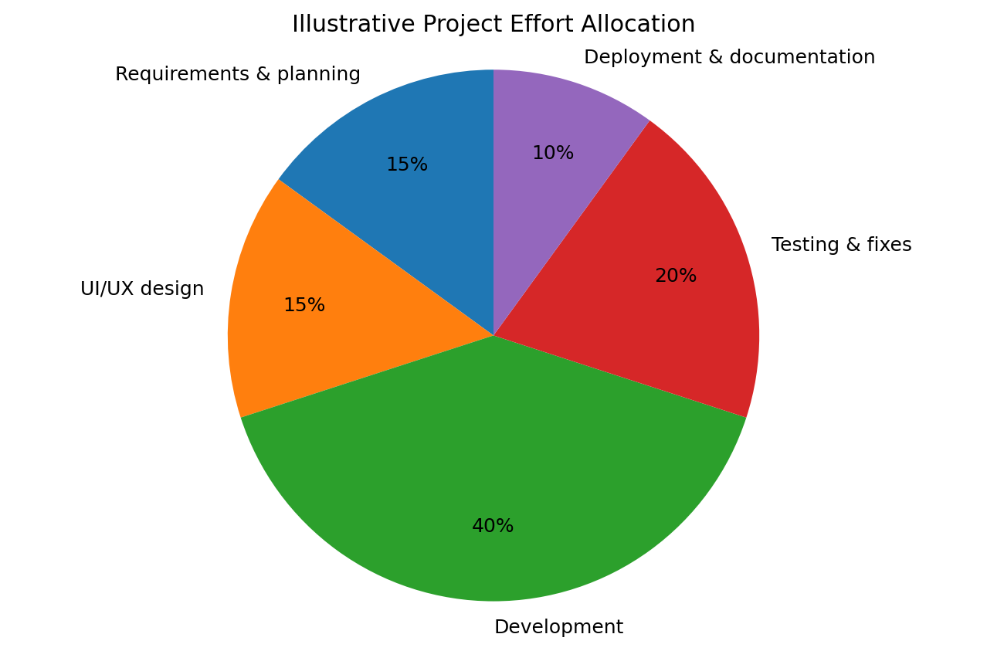
Work area | Planned share | Why this allocation is reasonable
Requirements & planning | 15% | Clarifies features, acceptance criteria, and scope before coding.
UI/UX design | 15% | Defines page structure, user journeys, seat selection, and responsive layouts.
Development | 40% | Largest effort: frontend, backend, database, booking rules, and admin functions.
Testing & fixes | 20% | Checks end-to-end journeys, booking conflicts, errors, security, and device layouts.
Deployment & documentation | 10% | Prepares demo deployment, setup instructions, screenshots, and final report.
TOTAL | 100% | The five planned shares add up to the full project effort.

Example conversion: if the project is estimated at 100 total work-hours, 40% for development means about 40 hours. If the estimate changes, multiply the total hours by each percentage.

12. Resources and Tools
Resource | Purpose | Status / notes
Laptop and internet | Development, testing, research, and deployment. | [Confirm available]
IDE and Git repository | Editing, version control, and collaboration. | [Enter selected tools]
UI design tool | Wireframes and interface mockups. | [Optional / selected tool]
Database and API testing tool | Data modelling and endpoint validation. | [Enter selected tools]
Test data / sample movie images | Demonstration without relying on live cinema data. | Use licensed or permitted assets.
Hosting / deployment | Make the demo accessible to reviewers. | [Select after application is stable]

13. Risk Register and Mitigation Plan
Risk | Likelihood / impact | Prevention or mitigation | Contingency
Scope grows during development | Medium / High | Freeze MVP features; record change requests. | Move optional features to a future phase.
Seat double-booking bug | Medium / High | Recheck availability server-side and use database transactions/constraints. | Reject conflicting request and ask user to choose again.
API/database integration delay | Medium / Medium | Agree data contracts early; use sample data and small integration tests. | Build a minimal mock endpoint while fixing integration.
Authentication/admin access weakness | Low–Medium / High | Apply server-side role checks and validate inputs. | Disable affected admin route until corrected.
Limited time or team availability | Medium / High | Prioritize Must-have features and review progress weekly. | Reduce optional scope; preserve core booking flow.
Deployment/configuration failure | Medium / Medium | Document environment variables and test deployment early. | Present a local demo and explain deployment blocker.
Unavailable or unlicensed images/data | Medium / Medium | Use permitted demo assets and clearly label sample data. | Replace with placeholder artwork/sample records.

14. Testing and Acceptance Checklist
Test ID | Test scenario | Expected result | Status
T-01 | Open catalogue and search for a movie. | Results and no-results state work. | [Not started]
T-02 | Open movie and choose a valid showtime. | Correct showtime details are displayed. | [Not started]
T-03 | Select and deselect seats. | Selection and price summary update correctly. | [Not started]
T-04 | Submit booking with missing/invalid required fields. | Helpful validation appears; no booking is created. | [Not started]
T-05 | Submit a valid booking. | Booking reference and correct summary are displayed. | [Not started]
T-06 | Try booking a seat that became unavailable. | Server rejects conflict and asks user to refresh/reselect. | [Not started]
T-07 | Open admin function as non-admin. | Access is denied. | [Not started]
T-08 | Use the main journey on mobile and desktop widths. | Controls and content remain usable. | [Not started]
T-09 | Trigger an API/network error. | Clear error appears; no false confirmation is shown. | [Not started]

15. Communication and Progress Tracking
Activity | Frequency | What to record
Team progress review | Once per week (or more often for a short sprint) | Completed tasks, next tasks, blockers, and decisions.
Task-board update | Whenever task status changes | Owner, priority, due date, status, and evidence.
Risk review | Weekly and before major milestones | Likelihood, impact, mitigation owner, and next action.
Scope-change review | Whenever a new feature is requested | Reason, effort impact, schedule impact, and approval.
Demonstration / review | At each major milestone | What works, what is incomplete, feedback, and sign-off.

16. Change Control
Any proposed feature or schedule change should be recorded with its reason, expected benefit, estimated effort, impact on existing work, and decision. The project lead/reviewer should approve or reject the change before it is treated as committed scope. Keep the original scope and the approved updated scope traceable.

17. Deliverables and Final Handover
Deliverable | Contents / completion check
Working web application | Core movie discovery and booking journey works in the agreed demo environment.
Source code repository | Organized code, meaningful commits, and no committed secrets/API keys.
Database design | ER diagram/schema and sample data instructions.
Project documentation | Overview, features, architecture, installation, environment setup, and known limitations.
Test evidence | Test cases, results, known defects, and screenshots where appropriate.
Final presentation | Problem, solution, planning scenarios, architecture, demo, testing, and future improvements.

18. Template Usage Notes
- Replace bracketed fields with your actual project details, team names, confirmed technology stack, and dates.
- Treat the six-week schedule and pie-chart percentages as a starting estimate, not a fixed promise.
- Mark each task as Not started, In progress, Blocked, or Complete and record evidence for completed items.
- Keep the first release focused on the core user journey: browse movie → choose showtime → select seats → confirm booking.
- Add real payment integration only if it is explicitly required and approved; use a sandbox for demonstrations.

— End of Project Planning Template —

